**Following is the project layout:**

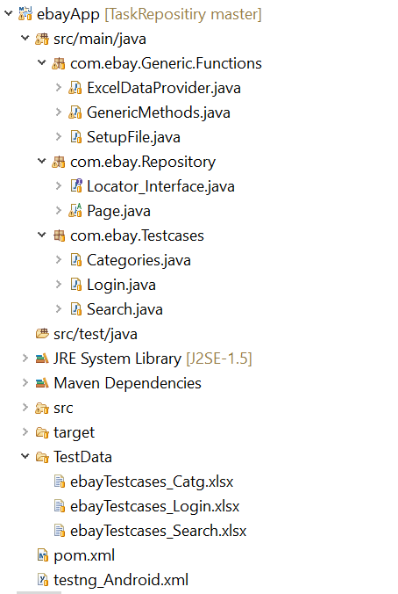

***Packages we use:***

* **com.ebay.Generic.Functions**

All common classes which will be used throughout the project are maintained here. It contains three major different classes.

1.Excel Data Provider: This contains all common methods related to excel. This will be used to read test data.

2.Generic Methods: This contains all java methods that are generic to project.

3.Setup File: This will handle all required capabilities to interact with Appium server and code.

* **com.ebay.Repository**

All xpaths related to app will be maintained here in locator interface.

* **com.ebay.Testcases**

All test cases will be organized here module wise.

* **TestData**

* All test case related test data excel sheets will be maintained here in one folder.
* All the testcases will be executed based on the execution status in excel.
* If the execution status is “Y” test case will be executed else it will be skipped.
* **POM Xml:**

All dependencies will be maintained here.

* **Android_XML:**

In this we can pass all desired capabilities, test case names which we want to be executed dynamically.

**Execution Flow:**

1. Start Appium server manually at host 127.0.0.1 and port 4723.
2. Modify capabilities based on the requirement in testng_android_Xml.
3. Mention all the class name which needs to be executed in testng_android_Xml.
4. Execute testng_android_xml using testing.
5. Now Testng will execute all the classes mentioned based in the xml.
6. After execution results will be saved in Testng-Output folder.
7. For more details about execution, we can go through “Emailable report” in output folder.
8. Now we can stop the server.